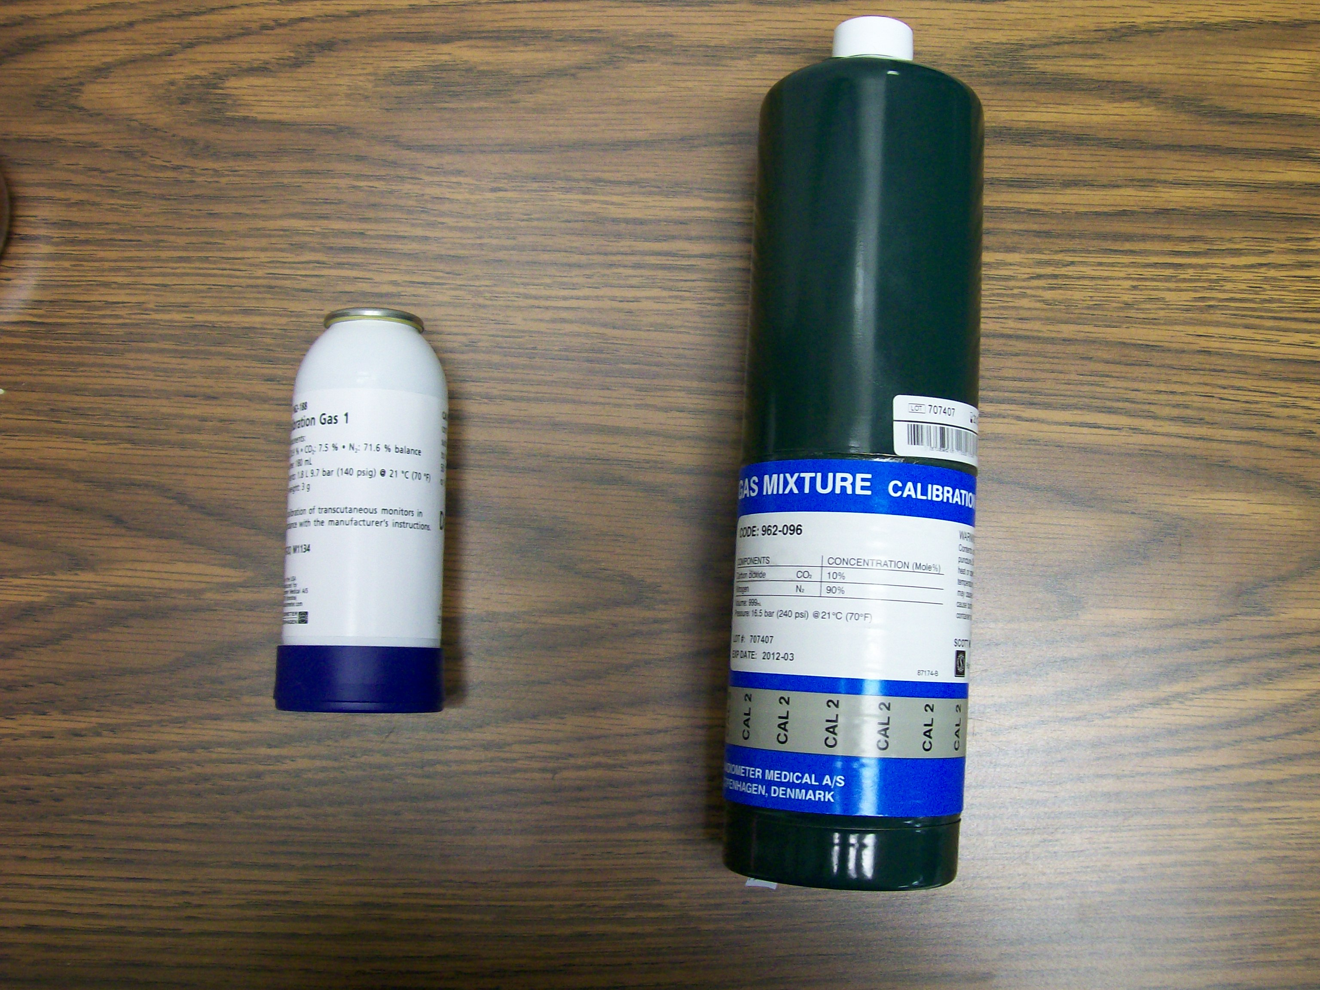
962-188
Tcpo2 calibration gas
962-096
Electrode zeroing gas which replaced the zero solution.

