TEED SCALE DESCRIPTIONS
Grade 0 - No visible damage, normal ear  Grade 1 - Congestion around the umbo; occurs with a pressure differential of 2 pounds per square inch (PSI)  Grade 2 - Congestion of entire TM; occurs with a pressure differential of 2-3 PSI  Grade 3 - Hemorrhage into the middle ear  Grade 4 - Extensive middle ear hemorrhage with blood bubbles visible behind TM; TM may rupture  Grade 5 - Entire middle ear is filled with dark (deoxygenated) blood | 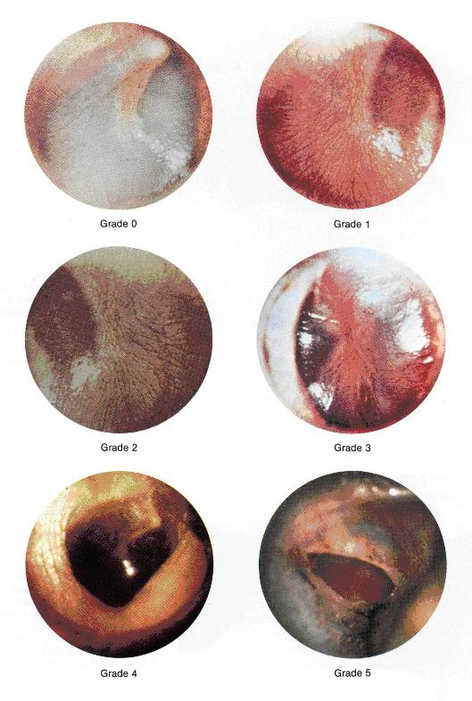

Close Window

